**Safe travels project**

**Introduction:** Meghalaya is one of the seven sister states in North East India which is home to a variety of fauna and flora. It is divided into 12 districts, each of them having their unique features. Its latitudinal extent ranges from 20°1'N - 26°5'N and its longitudinal extent ranges from 85°49'E - 92°52'E.

**Aim of the project**: The project aimed to collect data from different places and different districts of Meghalaya which are crucial to both the locals and tourists as well while giving them the current status and information of that area with regards to the climatic and weather conditions, whether it is feasible to travel to the said place or not.

**Tasks undertaken**:

* Worked in the report(2010-19) making of IMD Shillong.
* Collected data from different sources to get the names of places like hospitals, schools, police stations, tourist spots etc.
* Collected latitudes and longitudes of the places mentioned above.
* Worked with QGIS to plot layers to get a map with the different places as layers.

**Methodology**:

* For the report making, MS Word was used to compile the data into tables and display a graph corresponding to the data.
* For data collection of the names of places, the following websites were used:
* https://schools.org.in/meghalaya
* https://www.meghealth.gov.in/hospitals.html
* QGIS was used to plot layers and display a map.
* Visited the Department of Economics & Statistics, Shillong to obtain some data.

CLIMATOLOGY FOR MEGHALAYA STATIONS

(2010-2019)

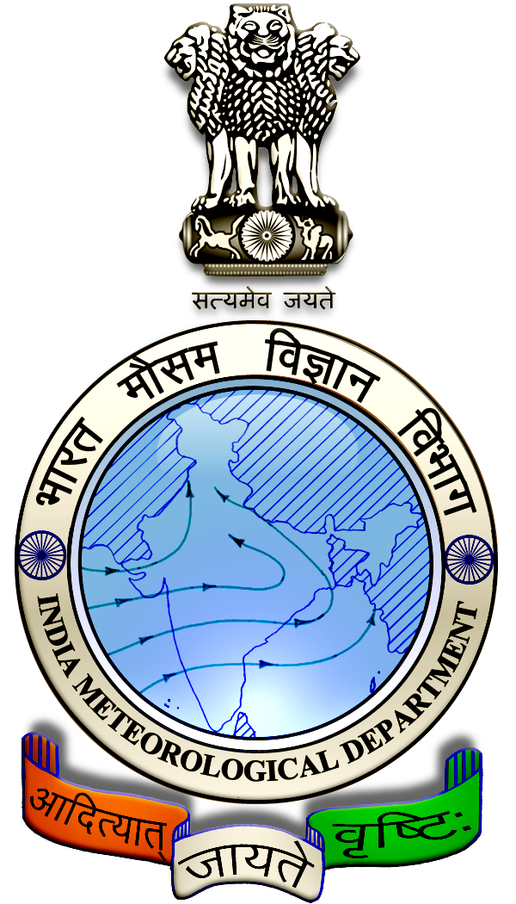

Station: Shillong (42516)

Meteorological Centre Shillong

India Meteorological Department

Ministry of Earth Sciences

Government of India

|  |  |  |  |  |  |
| --- | --- | --- | --- | --- | --- |
| Months | Rainy Days | Light Rain days | Moderate Rainy days | Heavy rainy days | Extremely heavy rainy days |
| January | 2.9 | 1.2 | 0 | 0 | 0 |
| February | 2.6 | 1.3 | 0.2 | 0 | 0 |
| March | 7.7 | 3.4 | 0.3 | 0 | 0 |
| April | 16.6 | 7.6 | 2.7 | 0 | 0 |
| May | 23.6 | 12.7 | 4.1 | 0.3 | 0 |
| June | 25.5 | 10.2 | 6.8 | 1.2 | 0 |
| July | 25.3 | 10.8 | 5.2 | 0.6 | 0 |
| August | 24.8 | 10.9 | 5.3 | 1.5 | 0 |
| September | 23 | 8.5 | 5.4 | 0.6 | 0.1 |
| October | 14.5 | 4.3 | 3.2 | 0.3 | 0 |
| November | 4 | 1.3 | 0 | 0 | 0 |
| December | 2.1 | 0.5 | 0.1 | 0 | 0 |
| Winter | 5.5 | 2.5 | 0.2 | 0 | 0 |
| Pre-Monsoon | 47.9 | 23.7 | 7.1 | 0.3 | 0 |
| Monsoon | 98.6 | 40.4 | 22.7 | 3.9 | 0.1 |
| Post-Monsoon | 20.6 | 6.1 | 3.3 | 0.3 | 0 |
| Annual | 172.6 | 72.7 | 33.3 | 4.5 | 0.1 |

Table 1. Monthly mean rainfall intensity frequency (days) at Shillong

Figure 1. Monthly mean rainfall intensity frequency (days) at Shillong

Hail

Table 2. Monthly mean number of days with hail in Shillong

|  |  |
| --- | --- |
| Months | No. of days |
| January | **0.3** |
| February | **0.3** |
| March | **0.9** |
| April | **1** |
| May | **0.4** |
| June | **0.1** |
| July | **0** |
| August | **0.1** |
| September | **0.1** |
| October | **0.1** |
| November | **0** |
| December | **0** |

Figure 2. Monthly mean number of days with hail in Shillong

**Thunder**

**Table 3. Monthly mean number of days with thunderstorms in Shillong**

|  |  |
| --- | --- |
| Month | No.of days |
| January | 1.2 |
| February | 1.3 |
| March | 4.5 |
| April | 14.5 |
| May | 14.9 |
| June | 9.8 |
| July | 4.3 |
| August | 11.4 |
| September | 11 |
| October | 6.8 |
| November | 0.7 |
| December | 0.0 |

Figure 3. Monthly mean number of days with thunderstorms in Shillong

**Station: Sohra (42515)**

Table 4. Figure 4. Monthly mean rainfall intensity frequency (days) at Sohra(Cherrapunjee)

|  |  |  |  |  |  |
| --- | --- | --- | --- | --- | --- |
| Months | Rainy Days | Light Rain days | Moderate Rainy days | Heavy rainy days | Extremely heavy rainy days |
| January | 1.8 | 0.6 | 0.1 | 0 | 0 |
| February | 2.8 | 0.8 | 0.7 | 0.3 | 0.1 |
| March | 8.7 | 2.8 | 2.4 | 1.5 | 0.4 |
| April | 20.5 | 6.2 | 7.4 | 4.7 | 1 |
| May | 25.5 | 7.6 | 9.4 | 5.2 | 0.9 |
| June | 26.6 | 4.5 | 9.4 | 9.8 | 3.7 |
| July | 29.2 | 4.7 | 10.3 | 12 | 2.4 |
| August | 24.8 | 5.7 | 8.3 | 8.1 | 2.1 |
| September | 22.3 | 6.5 | 6.5 | 5.7 | 1 |
| October | 10 | 2.8 | 1.9 | 2 | 0.6 |
| November | 2.4 | 0.9 | 0.5 | 0 | 0 |
| December | 1.6 | 0.9 | 0.3 | 0 | 0 |
| Winter | 4.6 | 1.4 | 0.8 | 0.3 | 0.1 |
| Pre-Monsoon | 54.7 | 16.6 | 19.2 | 11.4 | 2.3 |
| Monsoon | 102.9 | 21.4 | 34.5 | 35.6 | 9.2 |
| Post-Monsoon | 14 | 4.6 | 2.7 | 2 | 0.6 |
| Annual | 176.2 | 44 | 57.2 | 49.3 | 12.2 |

Figure 4. Monthly mean rainfall intensity frequency (days) at Sohra(Cherrapunjee)

**Hail**

**Table 5. Monthly mean number of days with hail in Sohra (Cherrapunjee)**

|  |  |
| --- | --- |
| Months | No.of days |
| January | 0 |
| February | 0.1 |
| March | 0 |
| April | 0.7 |
| May | 0.1 |
| June | 0.2 |
| July | 0 |
| August | 0 |
| September | 0.1 |
| October | 0 |
| November | 0 |
| December | 0 |

Figure 5. Monthly mean number of days with hail in Sohra (Cherrapunjee)

**Thunder**

**Table 6. Monthly mean number of days with thunder in Sohra (Cherrapunjee)**

|  |  |
| --- | --- |
| Months | No.of days |
| January | 0.4 |
| February | 1 |
| March | 3.9 |
| April | 14.1 |
| May | 12.4 |
| June | 7.9 |
| July | 3.3 |
| August | 3.6 |
| September | 5.9 |
| October | 2.9 |
| November | 0.4 |
| December | 0.1 |

Figure 6. Monthly mean number of days with thunder in Sohra (Cherrapunjee)

**Station: Barapani (42512)**

Table 7. Monthly mean rainfall intensity frequency (days) at Barapani

|  |  |  |  |  |  |
| --- | --- | --- | --- | --- | --- |
| Months | Rainy Days | Light Rain days | Moderate Rainy days | Heavy rainy days | Extremely heavy rainy days |
| January | 2.6 | 1.2 | 0.1 | 0 | 0 |
| February | 1.7 | 1.2 | 0 | 0 | 0 |
| March | 6.5 | 2.5 | 0.9 | 0 | 0 |
| April | 15.5 | 9.2 | 2.2 | 0 | 0 |
| May | 24.2 | 10.5 | 5.9 | 0.3 | 0 |
| June | 25.1 | 11.5 | 6.3 | 0.9 | 0 |
| July | 25.6 | 10.8 | 5.5 | 0.2 | 0 |
| August | 26.1 | 9.6 | 6.6 | 0.8 | 0 |
| September | 23.8 | 11.4 | 6 | 0.4 | 0 |
| October | 18.3 | 7.3 | 4 | 0.2 | 0 |
| November | 5.1 | 1.4 | 1 | 0 | 0 |
| December | 2.2 | 0.3 | 0.1 | 0 | 0 |
| Winter | 4.3 | 2.4 | 0.1 | 0 | 0 |
| Pre-Monsoon | 46.2 | 22.2 | 9 | 0.3 | 0 |
| Monsoon | 100.6 | 43.3 | 24.4 | 2.3 | 0 |
| Post-Monsoon | 25.6 | 9 | 5.1 | 0.2 | 0 |
| Annual | 176.7 | 76.9 | 38.6 | 2.8 | 0 |

Figure 7. Monthly mean rainfall intensity frequency (days) at Barapani

**Hail**

Table 8. Monthly mean number of days with hail in Barapani

|  |  |
| --- | --- |
| Month | No.of days |
| January | 0 |
| February | 0 |
| March | 0.2 |
| April | 0.1 |
| May | 0.3 |
| June | 0 |
| July | 0 |
| August | 0 |
| September | 0 |
| October | 0.1 |
| November | 0 |
| December | 0 |

Figure 8. Monthly mean number of days with hail in Barapani

**Thunder**

**Table 9. Monthly mean number of days with thunder in Barapani**

|  |  |
| --- | --- |
| Month | No.of days |
| January | 0.7 |
| February | 1 |
| March | 3.7 |
| April | 8.9 |
| May | 12.5 |
| June | 10.9 |
| July | 5.5 |
| August | 11.5 |
| September | 12.8 |
| October | 7.7 |
| November | 0.8 |
| December | 0 |

Figure 9. Monthly mean number of days with thunder in Barapani

**Attached below are the data collected (places with their latitudes and longitudes)**

**Table 1: Details of police stations**

|  |  |  |  |  |
| --- | --- | --- | --- | --- |
| **Longitude** | **Latitude** | **gid** | **Name** | **District** |
| 91.86879 | 25.59839 | 1 | Mawlai Police Station | East Khasi Hills |
| 91.89957 | 25.66669 | 2 | Umiam Police Station | East Khasi Hills |
| 91.94539 | 25.59469 | 3 | Police Station | East Khasi Hills |
| 91.88183 | 25.5794 | 4 | Sadar Police Station | East Khasi Hills |
| 91.87299 | 25.58035 | 5 | Lumdiengjri Police Station | East Khasi Hills |
| 91.86979 | 25.57651 | 6 | Barapathar Police Station | East Khasi Hills |
| 91.8758 | 25.57789 | 7 | Laitumkhrah Police Station | East Khasi Hills |
| 91.8697 | 25.57646 | 8 | Jhalupara Police Station | East Khasi Hills |
| 91.87698 | 25.56238 | 9 | Laban Police Station | East Khasi Hills |
| 91.57728 | 25.29393 | 10 | Mawsynram Police Station | East Khasi Hills |
| 92.05855 | 25.55103 | 12 | Mawryngkneng Police Staion | East Khasi Hills |
| 91.76892 | 25.47752 | 13 | Mawngap Police Station | East Khasi Hills |
| 91.73295 | 25.27004 | 14 | Sohra Police Station | East Khasi Hills |
| 91.89082 | 25.31142 | 15 | Pynursla Police Station | East Khasi Hills |
| 91.91286 | 25.55839 | 16 | Madanriting Police Station | East Khasi Hills |
| 91.91354 | 25.56825 | 17 | Rynjah Police Station | East Khasi Hills |
| 92.05279 | 25.60374 | 18 | Diengpasoh Police Station | East Khasi Hills |
| 91.46979 | 25.36812 | 19 | Mawkyrwat Police Station | South West Khasi Hills |
| 91.24873 | 25.22165 | 20 | Ranikor Police Station | South West Khasi Hills |
| 91.6434 | 25.55723 | 21 | Mairang Police Station | Eastern West Khasi Hills |
| 91.26633 | 25.51964 | 22 | Nongstoin Police Station | West Khasi Hills |
| 90.85821 | 25.53252 | 23 | Shallang Police Station | West Khasi Hills |
| 91.8775 | 25.90651 | 24 | Nongpoh Sadar | Ri Bhoi |
| 91.89957 | 25.66669 | 25 | Umiam Police Station | Ri Bhoi |
| 91.83136 | 26.11669 | 26 | Khanapara Police Station | Ri Bhoi |
| 92.09216 | 25.8531 | 27 | Umsohlait Police Station | Ri Bhoi |
| 91.8872 | 25.75249 | 28 | Umsning Police Station | Ri Bhoi |
| 91.61232 | 25.88255 | 29 | Patharkhmah Police Station | Ri Bhoi |
| 92.19628 | 25.44229 | 30 | Jowai Police Station | West Jaintia Hills |
| 92.10559 | 25.28347 | 31 | Amlarem Police Station | West Jaintia Hills |
| 92.21713 | 25.57414 | 32 | Nartiang Police Station | West Jaintia Hills |
| 92.01942 | 25.18503 | 33 | Dawki Police Station | West Jaintia Hills |
| 92.39964 | 25.50134 | 34 | Raliang Police Station | West Jaintia Hills |
| 92.36338 | 25.3622 | 35 | Khliehriat Police Station | East Jaintia Hills |
| 92.61572 | 25.33079 | 36 | Saipung Police Outpost | East Jaintia Hills |
| 92.39282 | 25.17114 | 37 | Lumshnong police station | East Jaintia Hills |
| 90.21978 | 25.51236 | 38 | Tura PS | West Garo Hills |
| 90.3347 | 25.65078 | 39 | Jengjal PS | West Garo Hills |
| 90.21051 | 25.94804 | 42 | Tikrikilla PS | West Garo Hills |
| 90.2715 | 25.7367 | 43 | Damal Asim PS | West Garo Hills |
| 90.0337 | 25.89077 | 44 | Phulbari PS | West Garo Hills |
| 90.19726 | 25.72107 | 45 | Dadenggre PS | West Garo Hills |
| 89.9769 | 25.75248 | 46 | Rajabala PS | West Garo Hills |
| 89.93145 | 25.47375 | 47 | Ampati PS | South West Garo Hills |
| 89.85094 | 25.30327 | 48 | Mahendraganj PS | South West Garo Hills |
| 89.99833 | 25.40703 | 49 | Salmanpara PS | South West Garo Hills |
| 90.63712 | 25.9188 | 50 | Mendipathar PS | North Garo Hills |
| 90.61306 | 25.8938 | 51 | Resubelpara PS | North Garo Hills |
| 90.89814 | 25.92952 | 52 | Kharkutta PS | North Garo Hills |
| 90.51613 | 25.88921 | 53 | Bajengdoba PS | North Garo Hills |
| 90.60147 | 25.50994 | 54 | Williamnagar PS | East Garo Hills |
| 90.61088 | 25.65182 | 55 | Songsak PS | East Garo Hills |
| 90.43945 | 25.62874 | 56 | Chiading PS | East Garo Hills |
| 90.64357 | 25.19769 | 57 | Baghmara PS | South Garo Hills |
| 90.77767 | 25.20114 | 58 | Rongara PS | South Garo Hills |
| 90.65803 | 25.35235 | 59 | Siju PS | South Garo Hills |
| 90.70137 | 25.46128 | 60 | Nongalbibra PS | South Garo Hills |
| 90.42068 | 25.32179 | 61 | Chokpot PS | South Garo Hills |
| 90.48602 | 25.2545 | 62 | Silkigre PS | South Garo Hills |
| 90.25496 | 25.39316 | 63 | Sangknigre | South Garo Hills |
| 90.33937 | 25.19974 | 64 | Gasuapara PS | South Garo Hills |

**Table 2: Details of bus stops**

|  |  |  |  |  |
| --- | --- | --- | --- | --- |
| **Longitude** | **Latitude** | **gid** | **Name** | **District** |
| 91.8717 | 25.575 | 1 | Jalupara Bus Stand | East Khasi Hills |
| 91.8856 | 25.5657 | 2 | Malki Bus Stop | East Khasi Hills |
| 91.8906 | 25.5823 | 3 | Jawaharlal Nehru Stadium Bus Terminal | East Khasi Hills |
| 91.8839 | 25.5702 | 4 | Secretariat Bus Stop | East Khasi Hills |
| 91.9238 | 25.5901 | 5 | Itshyrwat Bus Stop | East Khasi Hills |
| 91.892968 | 25.6310394 | 6 | ISBT Shillong | East Khasi Hills |
| 91.8884759 | 25.5769117 | 7 | Police bazaarTaxi Stand Shillong | East Khasi Hills |
| 92.0189856 | 25.5376315 | 8 | Pommura Bus Stop | East Khasi Hills |
| 91.8774295 | 25.578561 | 9 | Jaiaw Taxi Stand | East Khasi Hills |
| 91.8766216 | 25.5759217 | 10 | Umlyngka Taxi Stand | East Khasi Hills |
| 91.8848191 | 25.5842826 | 11 | Lawmali Taxi Stand | East Khasi Hills |
| 91.9007568 | 25.6098897 | 12 | NEHU Bus Stand | East Khasi Hills |
| 91.8832 | 25.5668 | 13 | Barik Bus Stand | East Khasi Hills |
| 91.8766 | 25.5725 | 14 | Anjali Bus Stand | East Khasi Hills |
| 91.919 | 25.5701 | 15 | Lapalang Bus Stand | East Khasi Hills |
| 91.4729297 | 25.3868564 | 16 | Jaud Bus Stop | West Khasi Hills |
| 91.4710374 | 25.3908231 | 17 | Dom-iñdiñ Bus Stop | West Khasi Hills |
| 91.4605755 | 25.3923036 | 18 | Domthongkhlieh Bus Stand | West Khasi Hills |
| 91.2658927 | 25.5176986 | 19 | Wahriat Bus Stop | West Khasi Hills |
| 91.2475759 | 25.534576 | 20 | Siejlieh Bus Stand | West Khasi Hills |
| 91.46118 | 25.3680711 | 21 | Mawkyrwat Bus Station | South West Khasi Hills |
| 91.5347278 | 25.4060756 | 22 | Umjarain Bus Stand | South West Khasi Hills |
| 91.4527917 | 25.3609496 | 23 | Saitsnad Bus Stop | South West Khasi Hills |
| 91.4578664 | 25.3663277 | 24 | Lad Dispensary Bus Stop | South West Khasi Hills |
| 91.5421629 | 25.4044475 | 25 | Lawblei Umshit Bus Stop | South West Khasi Hills |
| 91.4842165 | 25.3921194 | 26 | Sawlad Bus Stop | South West Khasi Hills |
| 91.4689163 | 25.3998529 | 27 | Jashiar Bus Stop | South West Khasi Hills |
| 90.2150022 | 25.505439 | 26 | Dobasipara-Barengpara Bus Stations | West Garo Hills |
| 90.2068827 | 25.5043045 | 27 | Tura Bus Terminal | West Garo Hills |
| 90.215435 | 25.5078586 | 28 | South & West Garo Hills Bus Station | West Garo Hills |
| 90.2189729 | 25.5196181 | 29 | East Garo Hills Bus Stop | West Garo Hills |
| 90.0232279 | 25.5778467 | 30 | Garobadha Bus Stop | West Garo Hills |
| 90.6469335 | 25.1942876 | 31 | Baghmara Bus Station | South Garo Hills |
| 90.3448338 | 25.3571407 | 32 | Ganchikalak Bus Stand | South Garo Hills |
| 90.604873 | 25.5125596 | 33 | Williamnagar bus stand | East Garo Hills |
| 90.5168724 | 25.8905001 | 34 | Bajengdoba bus stand | East Garo Hills |
| 90.6085718 | 25.6491817 | 35 | Songsak Bus Stand | East Garo Hills |
| 90.6291068 | 25.7713829 | 36 | Dagal Bus Stop | East Garo Hills |
| 90.6261027 | 25.7879902 | 37 | Dandakol Bus Stand | East Garo Hills |
| 91.8777931 | 25.9085287 | 38 | Nongpoh Bus Stop | Ri Bhoi |
| 91.9005194 | 25.6738249 | 39 | Lad Umroi Bus Stop | Ri Bhoi |
| 91.9028771 | 25.6973802 | 40 | Sumer Bus Stop | Ri Bhoi |
| 92.3664615 | 25.3424607 | 41 | Diengchynrum Bus Stop | East Jaintia Hills |
| 90.6020379 | 25.9109316 | 42 | Bakra Bus Stand | North Garo Hills |

**Table 3: Details of Hospitals and health centres**

|  |  |  |  |  |
| --- | --- | --- | --- | --- |
| **Longitude** | **Latitude** | **gid** | **Name** | **District** |
| 91.8810813 | 25.56774 | 1 | Civil Hospital Shillong | East Khasi Hills |
| 91.8898463 | 25.56629 | 2 | Woodland Hospital | East Khasi Hills |
| 91.8658841 | 25.57693 | 3 | R P Chest Hospital Compound | East Khasi Hills |
| 91.8726986 | 25.5708 | 4 | Military Hospital | East Khasi Hills |
| 91.8979556 | 25.57138 | 5 | Nazareth Hospital | East Khasi Hills |
| 91.9113066 | 25.56098 | 6 | Supercare Hospital | East Khasi Hills |
| 91.8752718 | 25.58483 | 7 | Dr. H. Gordon Roberts Hospital | East Khasi Hills |
| 91.8844084 | 25.58373 | 8 | Ganesh Das Hospital | East Khasi Hills |
| 91.8929979 | 25.57314 | 9 | Civil Hospital Shillong | East Khasi Hills |
| 91.9135255 | 25.58801 | 10 | Neigrihms Hospital | East Khasi Hills |
| 91.9111941 | 25.56583 | 11 | Children's Hospital | East Khasi Hills |
| 91.9011971 | 25.56629 | 12 | Bethany Hospital | East Khasi Hills |
| 91.8979803 | 25.60327 | 13 | Sanker | East Khasi Hills |
| 92.1988731 | 25.4441 | 14 | Dr Norman Tunnel Hospital | West Jaintia Hills |
| 91.6306178 | 25.56043 | 15 | Holy Cross Hospital | Eastern West Khasi Hills |
| 90.1704088 | 25.5182 | 16 | Holy Cross Hospital | West Garo Hills |
| 91.6416349 | 25.56081 | 17 | Makarios Medical Centre | Eastern West Khasi Hills |
| 92.0969029 | 25.28735 | 18 | Rasongsli Nursing Home | West Jaintia Hills |
| 91.6330653 | 25.55412 | 19 | Civil Hospital Mairang | Eastern West Khasi Hills |
| 92.2608973 | 25.46782 | 20 | District civil hospital ialong | West Jaintia Hills |
| 91.2693956 | 25.52036 | 21 | Civil hospital Nongstoin | West Khasi Hills |
| 91.8768597 | 25.90952 | 22 | Civil Hospital Jowai | Ri Bhoi |
| 90.2037406 | 25.51468 | 23 | Civil Hospital Tura | West Garo Hills |
| 91.4575164 | 25.36602 | 24 | Civil Hospital Mawkyrwat | South West Khasi Hills |
| 89.9432013 | 25.49415 | 25 | Ampati Civil Hospital | South West Garo Hills |
| x | y | gid | Name | District |
| 91.90552 | 25.5605727 | 1 | Nongthymmai Urban Health Centre | East Khasi Hills |
| 91.9045524 | 25.5775281 | 2 | Demseiniong Urban Primary Health Centre | East Khasi Hills |
| 91.8719099 | 25.5937734 | 3 | Mawlai Nongkwar Urban Health Centre | East Khasi Hills |
| 91.8132479 | 25.5293143 | 4 | Pomlum Primary Health Centre | East Khasi Hills |
| 91.8989253 | 25.5969914 | 5 | Mawroh PHC | East Khasi Hills |
| 91.717186 | 25.5099477 | 6 | Sohiong CHC | East Khasi Hills |
| 91.7630709 | 25.5805024 | 7 | Krang Sub Centre | Eastern West Khasi Hills |
| 91.9542501 | 25.5819187 | 8 | Mawlynrei Sub Health Centre | East Khasi Hills |
| 91.476544 | 25.4804421 | 9 | Pariong PHC | West Khasi Hills |
| 91.971921 | 25.6653839 | 10 | Mawsiatkhnam PHC | East Khasi Hills |
| 91.2461844 | 25.5203698 | 11 | Nongstoin Urban Health and Wellness Centre | West Khasi Hills |
| 91.2697861 | 25.5204312 | 12 | Nongstoin CHC | West Khasi Hills |
| 91.4168636 | 25.4155658 | 13 | Mawthawpdah PHC | South West Khasi Hills |
| 91.9912023 | 25.4404622 | 14 | Mawkynrew PHC | East Khasi Hills |
| 91.9018682 | 25.5039556 | 15 | Smit PHC | East Khasi Hills |
| 91.9120048 | 25.3088676 | 16 | Pynursla CHC | East Khasi Hills |
| 91.641634 | 25.18038 | 17 | Majai Sub Health Centre | East Khasi Hills |
| 92.1336295 | 25.3208473 | 18 | Jarain PHC | West Jaintia Hills |
| 92.2228531 | 25.5760937 | 19 | Nartiang PHC | West Jaintia Hills |
| 91.8020441 | 25.4196687 | 20 | Swer PHC | East Khasi Hills |
| 92.1566754 | 25.5157163 | 21 | CHC Ummulong | West Jaintia Hills |
| 91.6119272 | 25.8824308 | 22 | Patharkhmah CHC | Ri Bhoi |
| 91.5788572 | 25.2955292 | 23 | Mawsynram CHC | East Khasi Hills |
| 92.3682359 | 25.3598416 | 24 | Khliehriat CHC | East Jaintia Hills |
| 91.7355459 | 25.2725203 | 25 | Sohra CHC | East Khasi Hills |
| 91.7901759 | 25.3211869 | 26 | Khrang PHC | East Khasi Hills |
| 90.2133345 | 25.5216592 | 27 | UPHC Tura | West Garo Hills |
| 90.0549872 | 25.7974491 | 28 | Mengkakgiri Health Sub Centre | West Garo Hills |
| 90.080762 | 25.7693588 | 29 | Korakona Health Sub Centre | West Garo Hills |
| 90.0226631 | 25.580455 | 30 | Garobadha PHC | West Garo Hills |
| 90.2133337 | 25.449999 | 31 | Bolchugre Health Sub Centre | West Garo Hills |
| 89.9602385 | 25.5170409 | 32 | Betasing PHC | South West Garo Hills |
| 90.1452402 | 25.352456 | 33 | Gonchudare Health Sub Centre | West Garo Hills |
| 89.9304929 | 25.4732524 | 34 | Ampati CHC | South West Garo Hills |
| 90.6042309 | 25.5012338 | 35 | Urban Health and Wellness Centre Williamnagar | East Garo Hills |
| 90.6367132 | 25.5160441 | 36 | Dawagre health sub centre | East Garo Hills |
| 90.7164323 | 25.5574842 | 37 | Dobu PHC | East Garo Hills |
| 90.5758643 | 25.5155452 | 38 | Bolkinggre Sub Centre | East Garo Hills |
| 90.4283334 | 25.7870778 | 39 | Rari PHC | North Garo Hills |
| 90.6103276 | 25.8996088 | 40 | Resubelpara CHC | North Garo Hills |
| 91.9777573 | 25.7207801 | 41 | Umroi PHC | Ri Bhoi |
| 91.8913054 | 25.7479386 | 42 | Umsning CHC | Ri Bhoi |

**Table 4 : Details of bridges**

|  |  |  |  |  |
| --- | --- | --- | --- | --- |
| **Longitude** | **Latitude** | **gid** | **Name** | **District** |
| 91.8882956 | 25.5817073 | 1 | Polo Bridge | East Khasi Hills |
| 91.889913 | 25.5667099 | 2 | Foot Over Bridge | East Khasi Hills |
| 91.8821852 | 25.5817529 | 3 | Wahingdoh Bridge | East Khasi Hills |
| 91.8513395 | 25.6037164 | 4 | Nongpathaw bridge | East Khasi Hills |
| 91.9066717 | 25.5794501 | 5 | Nongmynsong Bridge | East Khasi Hills |
| 91.8684828 | 25.571405 | 6 | Umshyrpi Bridge | East Khasi Hills |
| 91.8863759 | 25.5825481 | 7 | Lawmali Bridge | East Khasi Hills |
| 91.8732967 | 25.5874886 | 8 | Mawlai Bridge (Jingkieng Mawlai) | East Khasi Hills |
| 91.9437063 | 25.6783203 | 9 | Umden Mission Bridge | Ri Bhoi |
| 91.8809427 | 25.5871783 | 10 | Jaiaw Bridge | East Khasi Hills |
| 91.22753131 | 25.29747519 | 11 | Jadukata Bridge | West Khasi Hills |
| 91.7659453 | 25.1878526 | 12 | Sohbar Bridge | East Khasi Hills |
| 91.9946204 | 25.7105789 | 13 | Dwar Ksuid Bridge | Ri Bhoi |
| 92.018884 | 25.1901235 | 14 | Dawki Bridge | West Jaintia Hills |
| 91.6695915 | 25.7257519 | 15 | Khri River Bridge | Ri Bhoi |
| 91.8129621 | 25.6493866 | 16 | Umraleng bridge | Ri Bhoi |
| 91.8245158 | 25.4655347 | 17 | Umtyngar bridge | East Khasi Hills |
| 91.6213457 | 25.6263382 | 18 | Khawai bridge | Eastern West Khasi Hills |
| 91.4362998 | 25.3957086 | 19 | Umrilang bridge | Ri Bhoi |
| 91.7917096 | 25.4221551 | 20 | Mawkdok bridge | East Khasi Hills |
| 91.9048728 | 25.3135207 | 21 | Jingkieng Nongmadan | East Khasi Hills |
| 91.8775711 | 25.5902521 | 22 | Seng Khasi Bridge | East Khasi Hills |
| 91.47315 | 25.398204 | 23 | Jashiar Bridge | South West Khasi Hills |
| 91.9583609 | 25.4579996 | 24 | Jingkieng Kian Mawbah | East Khasi Hills |
| 91.9719996 | 25.4575745 | 25 | Jingkieng Umpyrdon | East Khasi Hills |
| 92.2192943 | 25.4387777 | 26 | Syntu ksiar bridge | West Jaini |
| 92.3445799 | 25.3467012 | 27 | Umsyllih bridge | East Jaintia Hills |
| 92.3151967 | 25.3652304 | 28 | Moolamanoh bridge | East Jaintia Hills |
| 92.1929721 | 25.5116615 | 29 | Chohchrieh bridge | East Jaintia Hills |
| 89.9323148 | 25.471936 | 30 | Ampati Daru Bridge | South West Garo Hills |
| 89.9179408 | 25.4790589 | 31 | Dufrigao bridge | South West Garo Hills |
| 89.9785095 | 25.5022661 | 32 | Arenggre bridge | West Garo Hills |
| 89.9254544 | 25.3809161 | 33 | Bhoirakupi Rongkai bridge | South West Garo Hills |
| 90.0351125 | 25.5309495 | 34 | Gittimgre bridge | West Garo Hills |
| 90.0829139 | 25.5650011 | 35 | Ghatgre bridge | West Garo Hills |
| 90.2001089 | 25.5266677 | 36 | Sonanpara bridge | West Garo Hills |
| 90.2335815 | 25.5319718 | 37 | Derrangitim bridge | West Garo Hills |
| 90.218825 | 25.5069833 | 38 | Akonngre 3rd bridge | West Garo Hills |
| 90.2089753 | 25.5168178 | 39 | Teteng Aja bridge | West Garo Hills |
| 90.593982 | 25.513263 | 40 | Nokgil A.we and Cha.chatgre bridge | East Garo Hills |
| 90.6018364 | 25.4987189 | 41 | Simsang Warima | East Garo Hills |
| 90.6041683 | 25.5005604 | 42 | Warimagre over bridge | East Garo Hills |
| 90.6187756 | 25.5057685 | 43 | Mrong bridge | East Garo Hills |
| 90.6179184 | 25.8982986 | 44 | Damring bridge | North Garo Hills |
| 90.6171227 | 25.8974509 | 45 | Dekachang new bridge | North Garo Hills |
| 90.6135379 | 25.8799244 | 46 | New jongla bridge | North Garo Hills |
| 90.6049783 | 25.907685 | 47 | Dimbil bridge | North Garo Hills |
| 90.6358401 | 25.2097702 | 48 | Baghmara bridge | South Garo Hills |
| 90.6309856 | 25.2098326 | 49 | Rompa bridge | South Garo Hills |

**Table 5: Details of power stations**

|  |  |  |  |
| --- | --- | --- | --- |
| **Longitude** | **Latitude** | **name** | **District** |
| 91.88738 | 25.58827 | Meghalaya Energy Corporation Ltd | East Khasi Hills |
| 91.86693 | 25.58689 | Meghalaya Power Distributor Corporation Ltd | East Khasi Hills |
| 91.91114 | 25.61616 | MEPDCL Substation | East Khasi Hills |
| 91.88492 | 25.58046 | Electricity Office Powerhouse | East Khasi Hills |
| 91.86076 | 25.71306 | Stage II Power Station MePGCL | Ri Bhoi |
| 91.81948 | 26.01143 | New Umtru Power Station | Ri Bhoi |
| 91.91329 | 25.59217 | Mawpat Substation | East Khasi Hills |
| 91.74392 | 25.83839 | Umiam Umtru Stage IV Power Station | Ri Bhoi |
| 91.90014 | 25.66441 | Meghalaya Power Generation Corporation Ltd | Ri Bhoi |
| 90.20538 | 25.56414 | Ganol Hydroelectric Power Project | West Garo Hills |
| 90.23226 | 25.54742 | Rongkon Sub Station | West Garo Hills |
| 90.70417 | 25.45542 | Old thermal power house Nongalbibra | South Garo Hills |
| 90.33268 | 25.65 | Jengjal Power Station | West Garo Hills |
| 89.9242 | 25.45946 | MeECL Power Transmission Sub Station Ampati | South West Garo Hills |
| 90.21802 | 25.43001 | Power house Chekwatgre | West Garo Hills |
| 91.78936 | 25.78477 | Umiam Umtru Stage III Power Station | Ri Bhoi |
| 92.19201 | 25.43597 | MECL Jowai | West Jaintia Hills |
| 92.44386 | 25.52274 | Mowkaiaw Power Station | West Jaintia Hills |
| 92.22848 | 25.23541 | Myntdu Leshka Power Plant | West Jaintia Hills |
| 92.20095 | 25.26312 | Myntdu Leshka Dam | West Jaintia Hills |
| 91.9115 | 25.61524 | 33/11KV Substation Umjarain | East Khasi Hills |
| 91.95862 | 25.25974 | Pongkhongmit nuclear power plant | East Khasi Hills |
| 91.74383 | 25.83834 | Nongkhyllem Power House | Ri Bhoi |

* **Schools/colleges/institutes**: 1180 entries
* **Religious places**: 312 entries
* **Tourist spots**: 192 entries
* **Airport/helipad**: 2 entries

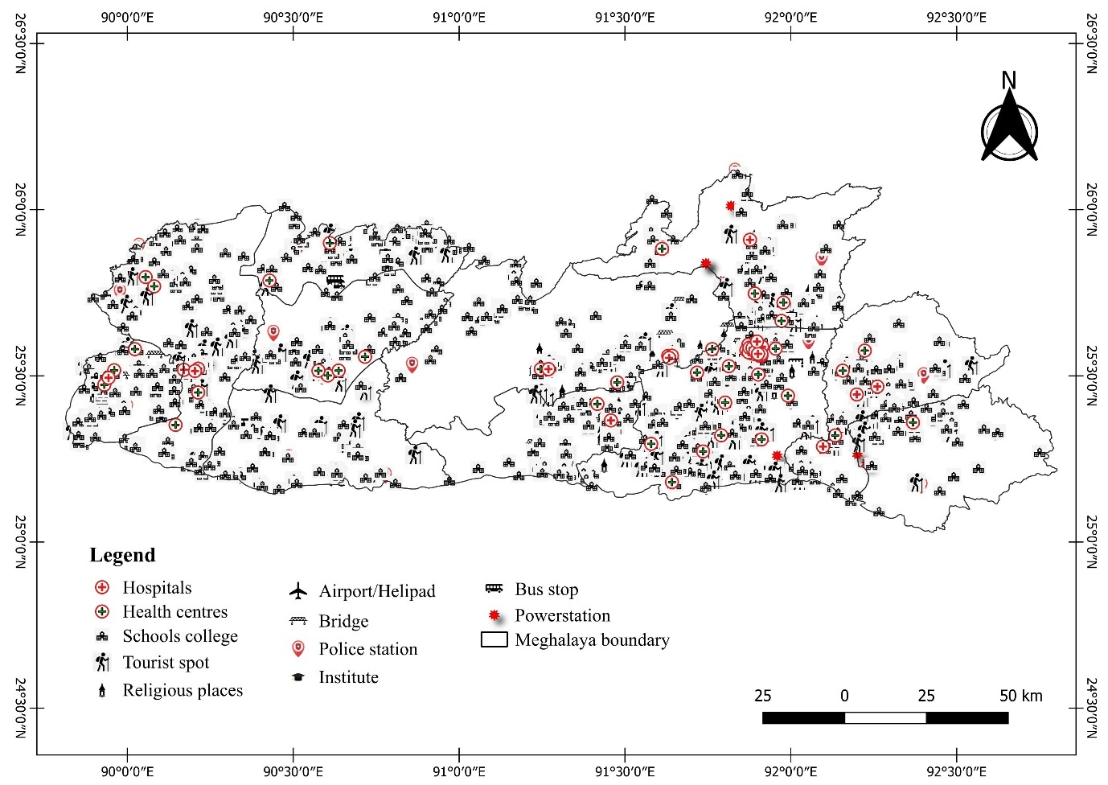

**Fig 1: Map with symbolic representations of different places**

**Challenges:**

* The latitude and longitude of many places could not be obtained on Google Earth/Google Maps, especially in rural areas.
* My limited knowledge of QGIS which was essential for several tasks.

**Conclusion**: By making real-time information on climatic and weather conditions, travellers can make informed decisions about their journeys, avoiding unsafe places due to adverse weather conditions. Ultimately, the project contributes to the region’s overall development by balancing tourism with the well-being of travellers.

**Acknowledgement**: I would like to thank Sir Thangjalal Lhouvum for giving me an opportunity to intern in the Indian Meteorological Department, Shillong. I would also like to thank Eva and Donald for helping and guiding me all the way through till the completion of the project.

**References**:

* https://schools.org.in/meghalaya
* https://www.meghealth.gov.in/hospitals.html